- Cash Receipts

Table of Contents
Cash Receipts 2
Payment/Receipt 3
Cash Distribution 5
Apply Credit 7

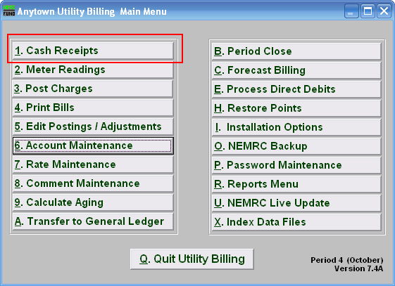

Click on “1. Cash Receipts” on the Main Menu. The following window will appear:

Cash Receipts

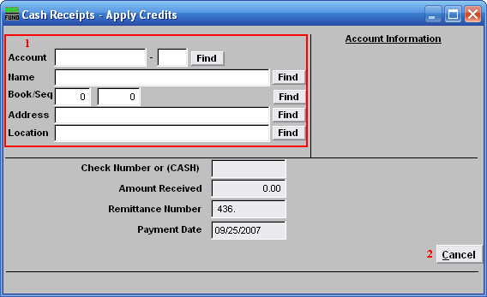
- Select the account you are seeking. For additional information on finding accounts, refer to UB GENERAL ACCOUNT LOOKUPS.

- Cancel: Click “Cancel” to return to the Main Menu.

After selecting the account (you may need to hit enter to bring it up) the following options will appear (if applicable):

Payment/Receipt

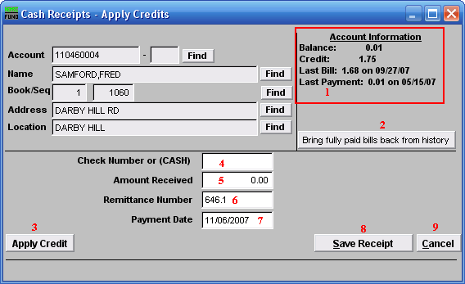
- Account Information: Information regarding this account.

- Bring fully paid bills back from history: Use to reverse a payment that was moved to history during a previous period close.

- Apply Credit: To apply a credit, click “Apply Credit” and the window will change slightly (see “Apply Credit” below).

- Check Number or (CASH): If the word cash is entered, the system will report cash totals separate from check totals. If the field is left blank, or a check number is written, it will be reported with Checks.

- Amount received: Enter payment received.

- Remittance Number: The remittance number is user defined and is transferred to General Ledger, if a link is established. Remittance Number and Payment Date should be uniform for all aspects of a deposit.

- Payment Date: Enter date that payment was made. Remittance Number and Payment Date should be uniform for all aspects of a deposit..

- Save Receipt: Click to post the payment to the account.

- Cancel: Click “Cancel” to cancel and return to the previous screen without posting.

Cash Distribution
When you enter an amount received, and click on “Save Receipt” the following window will appear:
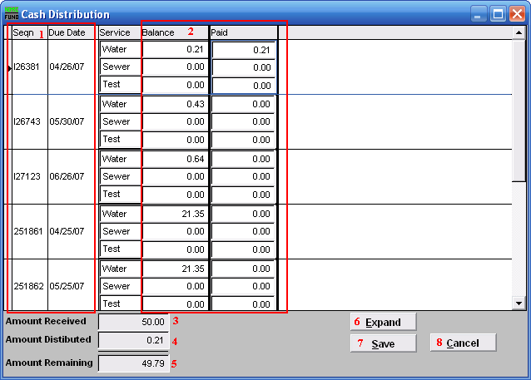
- Seqn: Sequence number for the due date (assigned by the system).
Due Date: Date that payment is due.

- Balance: Amount customer owes.
Paid: You may enter the Amount Received as it is to be applied to each service. You may also populate these fields automatically by hitting “enter” on your keyboard.

- Amount Received: Amount entered in previous screen for “Amount Received”.

- Amount Distributed: Portion of Amount Received that has been distributed as payment of charges.

- Amount Remaining: Amounts left to distribute from Amount Received.

- Expand: Click on “Expand” to view a brief history of the selected charge.

- Save: Click “Save” to save, and return to the first Cash Receipts screen.

Apply Credit
Click on the “Apply Credit” button and the following window will appear:

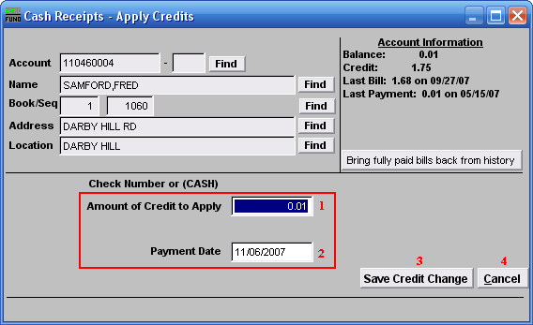
- Amount of Credit to Apply: Enter the amount of credit to apply (in dollars).

- Payment Date: Enter the date the credit is being applied.

- Save Credit Change: Click “Save Credit Change” to save the credit to this account.

- Cancel: Click “Cancel” to cancel and return to the first Cash Receipts screen without saving the credit.

